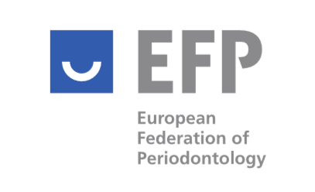

EFP CODE OF CONDUCT DECLARATION

The European Federation of Periodontology enjoys an excellent reputation in the dental community and with the public. This reputation depends in large measure upon the confidence the members, the dental community, and the public have in its integrity.

In this respect, the attached EFP Code of Conduct (CoC) sets out and explains the principles to be applied by the EFP, its member organisations, and all those involved in supporting the aims and objectives of the Federation.

For this reason, we kindly ask you to read carefully and acknowledge the EFP Code of Conduct and sign the following statement:

I ………………. certify that I have read, understood, and agree to comply with the EFP Code of Conduct, and for this purpose hereby sign this declaration.

Date:
Place:

Signature

Please return completed form by email to Mónica Guinea, monica@efp.org.

Disclaimer: This policy template is meant to provide general guidelines and should be used as a reference. It may not take into account all relevant local, state or federal laws and is not a legal document. Neither the author nor the EFP will assume any legal liability that may arise from the use of this policy.

